Contributor: Deborah Caplow

**Izquierdo, María**

(María Cenobia Izquierdo Gutiérrez)

Born: San Juan de los Lagos, Jalisco, 1902; Died: Mexico City, 1955

María Izquierdo was one of the most prolific Mexican easel painters of the twentieth century. Although she did not consider herself a surrealist, her work corresponded to **Surrealism** in its dreamlike and illogical imagery, often based on Mexican folk and popular art, Catholic religious practices, naïve portraiture, the circus, and her own personal life. She was especially admired by the French Surrealist poet **Antonin Artaud**, who visited her in Mexico City and wrote about her work. She studied at the Academy of San Carlos in the 1920s, and in the early 1930s she was involved with artist **Rufino Tamayo**. Her career was highly successful and she was the first Mexican woman to have an exhibition in the United States. Her series of watercolors of circus performers from the 1930s have an appealing spontaneity, and she also painted many still-lifes, landscapes and self-portraits, often with allegorical elements. Her work parallels that of **Frida Kahlo**, though they were not closely associated in their lifetimes, and, unlike Kahlo, Izquierdo produced a large body of work, often large in size and varied in subject matter. In 1948 she painted a dramatic self-portrait, *Sueño y presentimiento* (Dream and Premonition), in which she depicted herself holding her own decapitated head.

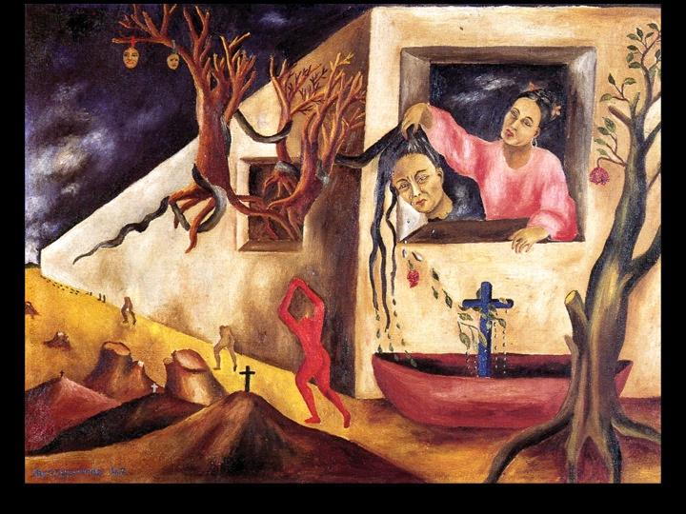

Maria Izquierdo, *Sueño y presentimiento* (Dream and Premonition), 1948, oil on canvas

https://www.google.com/search?q=izquierdo+dream+and+premonition&client=firefox-a&hs=AKv&rls=org.mozilla:en-US:official&channel=sb&tbm=isch&tbo=u&source=univ&sa=X&ei=lXp5U-DiO4WxoQSJioCgBw&ved=0CCUQsAQ&biw=1008&bih=522#imgdii=_

Izquierdo lost both parents at an early age and was raised by strict Catholic grandparents and an aunt. She was forced into an arranged marriage at the age of fourteen, to Cándido Posadas, a colonel in the Mexican army, and had three children by him. They moved to Mexico City in 1920, and she left the marriage in 1923 to live independently. She developed an interest in art, and in 1927 she enrolled the Escuela Nacional de Bellas Artes (National School of Fine Arts) known as the Academy of San Carlos. Muralist Diego Rivera praised her work and promoted her career, arranging her one-person show at the Galería de Arte Moderno in 1929; as a result of Rivera’s favoritism Izquierdo became unpopular with other students and she withdrew from the academy in 1931.

In 1930, she was the first Mexican woman to have a solo exhibition in the United States, at the Arts Center in New York, organized by Frances Flynn Paine, an important American patron of Mexican art. From 1929 to 1933, she lived with Tamayo and shared a studio with him; their work at this time is remarkably similar and it is unknown to what extent they influenced each other. Izquierdo’s 1930 *Niñas* *dormiendo* (Sleeping Children*)* depicts her children, painted simply in dark colors, with thick black outlines, similar to works like Tamayo’s 1930 *Desnudo en rojo* (Nude in Red), a portrayal of Izquierdo herself. After separating from Tamayo, Izquierdo went on to have a very successful career, with numerous solo exhibitions.

In the 1930s her palette and the themes of her paintings became lighter. She created a number of watercolor paintings of the circus, a favorite entertainment among artists at this time. She painted a number of dreamlike images in a naïve style, such as her 1935 *Paisaje con cebra y barco* (Landscape with Zebra and Ship), which depicts a barren setting with a zebra watching a boat, painted in primary colors, and she depicted rural life in whimsical ways, portraying farms and landscapes with illogical proportions and childlike forms. Surrealist writer Antonin Artaud met Izquierdo in Mexico City in 1936, afterward praising her in several articles; he also took a collection of her watercolors to Paris and exhibited them there in 1937. She was associated with the Contemporáneos, writers and artists who took an apolitical, modernist approach, but in the 1930s, she was also active in the Liga de Artistas y Escritores Revolucionarios (League of Revolutionary Artists and Writers, LEAR).

Izquierdo focused on women’s experience in numerous self-portraits and still-lifes. Like Kahlo, Izquierdo explored the theme of female identity. Her self-portraits range from straightforward, simplified representations set against plain backgrounds, to visionary works such as *Dream and Premonition*. She also painted allegorical figures; her 1943 *Maternidad* (Maternity) is a secular Madonna and Child, and the 1945 *La Tierra, dolor* (The Earth, Suffering) portrays a monumental figure in a deserted landscape, draped in a white cloth. She sewed many of her own clothes, and typically wore heavy makeup and ornate jewelry, which often appear in her paintings. In her 1940 *Mis Sobrinas* (My Nieces) she wears a blouse that she later depicted in *El alajero* (The Jewelry Box)of1942. In *El alajero* her clothing, jewelry, parasol, gloves, high heels and fan reference the absent Izquierdo, offering an intimate view of her personal world. Many of her still-lifes portray altars; some contain references to Easter, including the Virgin Mary as the Mater Dolorosa, and others refer to the Day of the Dead. Her cupboard paintings are based on a nineteenth-century genre of *alacena* painting, and present arrays of traditional Mexican food, toys, vessels and other objects.

In 1945, Izquierdo received a government commission for a mural in Mexico City. However, Rivera and muralist David Alfaro Siqueiros claimed that she was not skilled enough, and Izquierdo was not allowed to complete the project. She suffered a stroke in 1948, soon after she painted *Sueño y presentimiento*, and was in ill health until her death, also of a stroke, in 1955.

A major retrospective of her work took place in Mexico City at the Centro Cultural/Arte Contemporáneo in 1988 and 1989, and another exhibition of her paintings was held at the Museo de Arte Moderno in 2013.

**References and Further Reading**

Ferrer, E. (1997) *True Poetry: The Art of Maria Izquierdo*. New York: The Americas Society.

Greely, R. (2000) “Painting Mexican Identities: Nationalism and Gender in the Works of Maria Izquierdo.” *Oxford Art Journal*: (23), 1, 53-71.

Mexican Fine Arts Center Museum (1996) *Maria Izquierdo 1902-1955*. Chicago: Mexican Fine Arts Center Museum.

*Maria Izquierdo* (1988)Mexico City: Centro Cultural/Arte Contemporaneo*.*

Viscoli, M. (2010) *The Revolution of Maria Izquierdo: Constructs of Gender and Nation in the Artist’s Female Figures.* Master’s Thesis, California State University, Long Beach.

List of Works:

*Niñas* *dormiendo* (Sleeping Children*)*, 1930, oil on canvas.

*Paisaje con cebra y barco* (Landscape with Zebra and Ship), 1935, oil on canvas.

*Mis Sobrinas* (My Nieces), 1940, oil on canvas.

*El alajero* (The Jewelry Box)*,* 1942, oil on canvas

*Maternidad* (Maternity), 1943, oil on canvas

*Viernes de Dolores* (Friday of Sorrows), 1944-45, oil on canvas

*La tierra, dolor* (The Earth, Suffering), 1945, oil on canvas

*Sueño y presentimiento* (Dream and Premonition), 1948, oil on canvas.